Creating instance automatically on aws console using python boto3 from a local machine .

Requirements
Local machine +vscode/pycharm IDE
Python latest version +pip +boto3
Aws secrete storage manager(ssm)

Create a directory boto3 and Open folder with vscode and install python +pip +boto3
In powershell :
>winget install --id Python.Python.3 -e
>python -m pip install --upgrade pip
>pip install boto3 -y
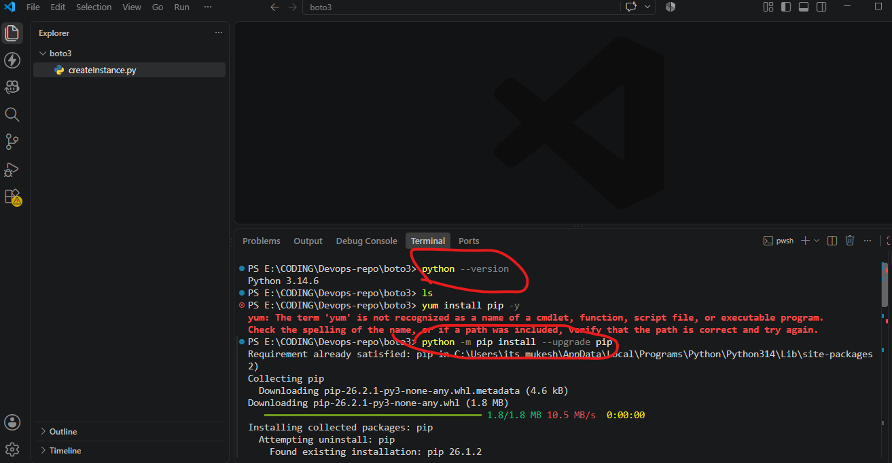

Create a file createInstance.py and include the code .
import boto3

ec2 = boto3.resource(
'ec2',
region_name='us-east-1'
)

instances = ec2.create_instances(
ImageId='ami-0bdc7d025135d7b49', # Replace with your AMI ID
MinCount=1,
MaxCount=1,
InstanceType='t3.micro',
KeyName='KeyNv', # Replace with your Key Pair name

NetworkInterfaces=[
{
"DeviceIndex": 0,
"SubnetId": "subnet-0af332bff2206ab95",
"AssociatePublicIpAddress": True,
"Groups": [
"sg-0c387840f4e73751c"
]
}
],

TagSpecifications=[
{
'ResourceType': 'instance',
'Tags': [
{
'Key': 'Name',
'Value': 'Python-Created-EC2'
}
]
}
]
)

print("Instance created successfully!")
print("Instance ID:", instances[0].id)

then configure your local machine for SSM connect (aws configure).
Get the access key and secrete access key from aws console
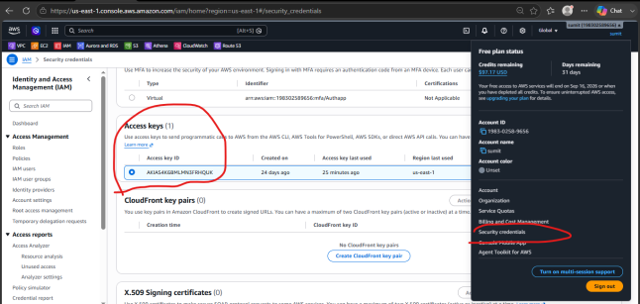
Or if you had already configured the credentials earlier you can find it on your local machine
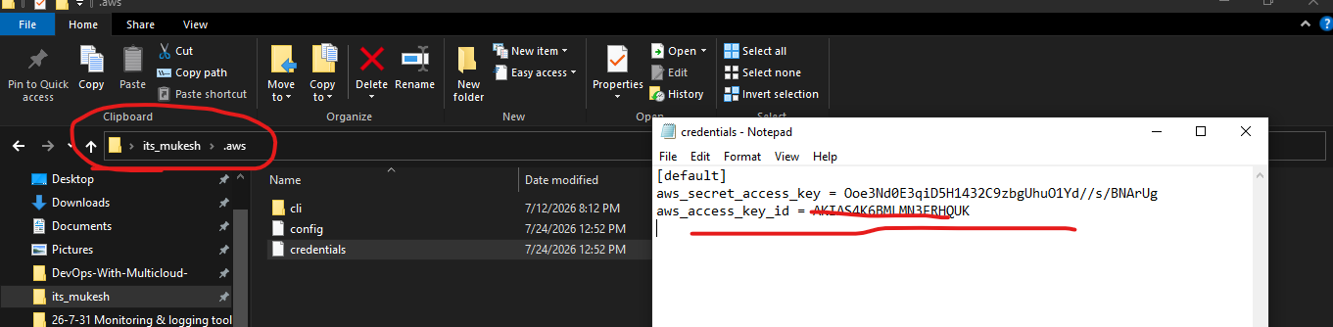

Now configure it on your local machine
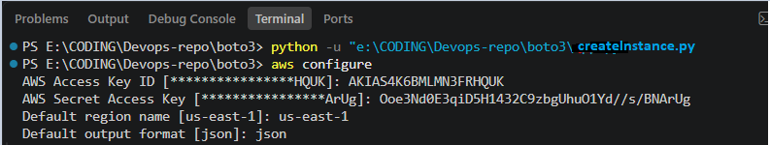
Now run the file createInstance.py
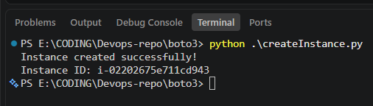
You can observe a new instance has been initiated .
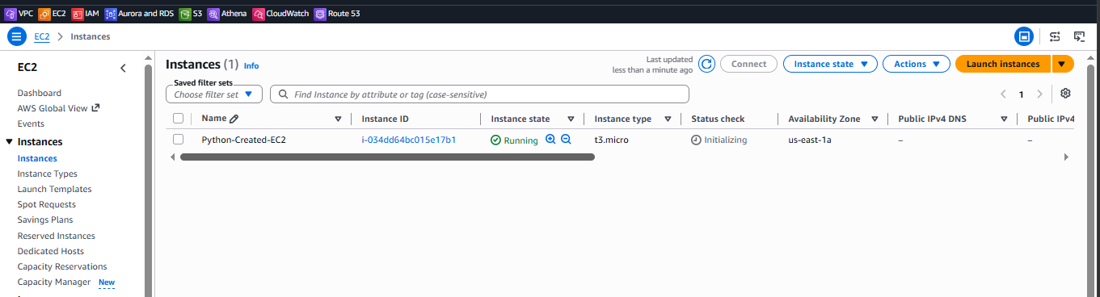

- Instead of hardening the credentials in python code locally we can use secrete manager to fetch the secrets from the aws console and include on the top of the python automate code.
- If a amazon resources , ex- ec2 instance try to automatically create a new instance then the instance should have AmazonEc2FullAcess role attached to it .
Task Over

